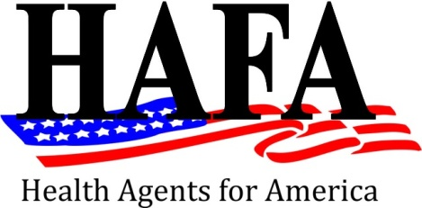
Application for Membership

Health Agents for America, Inc. is currently looking for Agents who plan to be in business and want to survive the Patient Protection and Affordable Care Act. In order to be considered as a HAFA member, you must be an “independent”, “non-captive” agent, with at least two (2) insurance contracts.

Now is the time that Agents need strong representation at your State and the Nation’s Capitol as Congress and State Legislatures are considering bills that could change or eliminate the Agent Community. HAFA is small enough to offer personal service and powerful enough to lead successful campaigns!

Print your Full Name and designations

Name of Your Company Your Title States Licensed

Street Address City State Zip

Telephone Fax E-Mail Address

Payment Enclosed: Amount: ____________ (Made payable to HAFA)

[ ] I am a Licensed, Independent & Non-Captive Insurance Agent
[ ] I am certified to Sell in the Marketplace
[ ] I sell Medicare Products
[ ] I sell Employer Group Products
[ ] Presidential Membership - $1,500 [ ] Senatorial Membership - $500 [ ] Congressional Membership - $18/Month
[ ] Please set me up for automatic monthly debit (attach form)
[ ] Please I would like to pay by credit card _____________________/______________/_____________/________
(2% processing) (Number) (Exp Date) (Security Code) (ZipCode)

[ ] As a Presidential Member, I would like to serve on the executive board
[ ] I would like my logo to be listed on the website (Presidential & Senatorial Only)

Mail To: HAFA
P O Box 65128
Baton Rouge, LA 70896
Fax to: 225-388-5400
Phone: 225-388-5400

(501© 6 Non-Profit Status)

